**CONVERSION of RGB to Thermal image:**

open cv, mathplotlib

1.convert RGB image to Greyscale

2.Them convert to Thermal Image

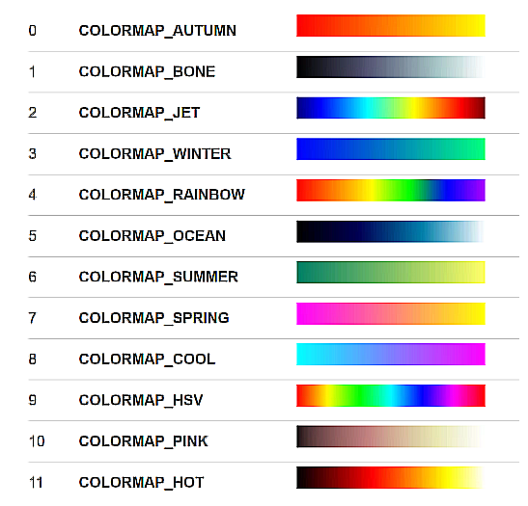

**Tensor flow:**

TensorFlow is an open-source software library for dataflow and differentiable programming across a range of tasks.TensorFlow provides a flexible and efficient platform for training machine learning models, as well as for deploying machine learning models in a production environment.TensorFlow provides a high-level API (Keras) for building and training models, as well as a low-level API for custom implementation. This makes it easy for both beginner TensorFlow includes a suite of visualization tools , which allow you to view the graph structure of your model

**Residual Neural Networks(ResNets)**

The main idea behind ResNet is to solve the vanishing gradients problem that occurs when training Convolutional neural networks. In traditional feedforward networks, the information from the input data tends to get diluted as it passes through multiple layers, making it difficult for the network to learn useful features. ResNet addresses this problem by introducing residual connections, where the input to each layer is added to the output of that layer before it is passed on to the next layer. This allows the network to learn the residual mapping between the input and the output, rather than trying to learn the complete mapping from scratch.

**Thermal imaging with fuzzy classifier for maturity and size based non-destructive Mango (Mangifera Indica L.) grading**

* L*a*b* color(Light, red ,yellow)
* The size, color and skin features are used with Fuzzy system for mango grading
* Classified into 2 classes

1. unripe and partially ripe mango with small or medium size
2. ripe or partially ripe mango with medium or big size.

* Ripeness of a mango is determined by the color feature extracted 2 mango on single images

Size of the mango is determined by Eccentricity ,

* Eccentricity < 0.7 then mango is Small

Eccentricity >= 0.7 and <= 0.74 then mango is Medium

Else Mango is Big

* Number of pixels < 17500 then mango is Small

Number of pixels >= 17500 and <= 20000 then mango is Medium

Else Mango is Big

* Weight < 200 then mango is Small

Weight >= 200 and <=300 then mango is Medium

Else Mango is Big

Size of Fruits is declared by using Eccentricity ,Area , Weight

* If Eccentricity = Small and Area = Small and Weight =Small then Small
* If Eccentricity = Small and Area = Medium and Weight=Medium then Medium
* If Eccentricity is Medium and Area = Big and Weight = Medium then Medium
* If Eccentricity is Medium and Area= Medium and Weight = Big then Big

Final Grading :

|  |  |  |
| --- | --- | --- |
| **Size** | **Maturity** | **Grade** |
| Big/medium | Unripe | 2 |
| Big/medium | Partially ripe ,Ripe | 1 |
| Small | Unripe , partially ripe | 2 |
| Small | Ripe | 1 |

